# Week 1

## Introduction to NoSQL

* Relational Databases
  + Data represented as tuples -> Rows
  + Set of tuples that all share same attributes is called relation -> Table
  + Schema: table, column names & types – stable over time – not expected to change
  + Primary keys uniquely identify rows within table
  + Foreign key fields are used in one table to refer to row in another table
  + Uses the Structured Query Language (SQL) – declarative approach to querying
  + Successful because
    - Persistence – keep large amounts of persistent data
    - Concurrency control – many users simultaneously
    - Integration machanisms – multiple apps written by different teams access same data
    - Standard model – devs can learn relational model and apply in many projects
* Why NoSQL?
  + Open source relational DBMS such as MySQL and Postgres became standard for Web applications (proprietary DBMS were expensive)
  + Applications and data requirements of key internet players began to outgrow relationsal DBMS; need for:
    - More flexible data models
    - Support for agile development
    - Consume large amounts of fast-incoming data from millions of users
    - Maintain high performance and uptime
  + Many companies use cloud apps, data issues common
* What is NoSQL?
  + New gen of databases that differ from Relational Model
  + New features and practices that are best suited for a new type of applications and ‘Big Data’
  + RDBs excel at maintaining consistency, but many sacrifice performance (Schema checks)
  + Limits to how big RDSs can scale
  + NoSQL DBs focus on **performance over consistency**
    - Data have structure, but without enforcing fixed schema
    - Data replicated across many nodes asynchronously
  + Definition: non-relational, distributed, open-source and horizontally scalable
    - Schema-free, simple API, easy replication support
    - BASE (not ACID)
  + NoSQL actually means “not only SQL”
* ACID vs BASE
  + ACID
    - Atomic- everything in a transaction succeeds or the entire transaction is rolled back
    - Consistent – transaction cannot leave database in an inconsistent state
    - Isolated – transactions cannot interfere with each other
    - Durable – completed transactions persist, even in presence of failures
  + BASE
    - Basic Availability – DB appears to work most of the time
    - Soft-state – DB doesn’t have to be write-consistent, nor do different replicas have to be mutually consistent
    - Eventual consistency – consistency after every transaction not required, it is enough to eventually be in a consistent state
  + Apps that need NoSQL
    - Social media, survey systems, IoT, search engines, geolocation, large complex apps
    - Highly variable data, unstructured data, does not fit into rigid schema easily
    - Unstructured data accounts for nearly 90% of data created today
  + Structured/Unstructured
    - Structured
      * Relational databases
      * Spreadsheets
      * Searchable
    - Unstructured
      * Text content, tweets, comments
      * Email, videos, audio
      * Clicks, likes, searches, followers
  + Big Data
    - Analysis of massive data sets
      * All of twitter or facebook
      * Web logs for major websites
      * Genome sequences of thousands of people
      * All images on Flickr
    - Exciting phenomenon
    - In practice, difficulties in working with large datasets
  + Datafication
    - Process of rendering into data aspects of the world that have never been quantified before
      * At personal level: friendship networks, lists of books we’re reading, films we enjoy, food we eat…
      * At business level: web activity logs, computer network activity, written reports, e-mails, voice recordings…

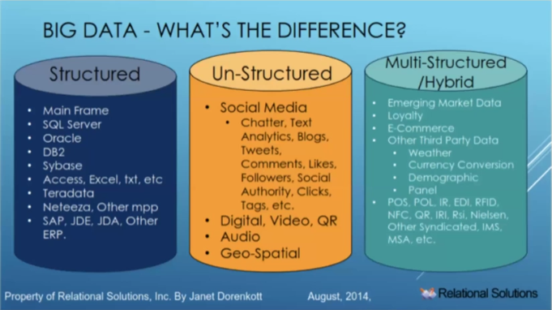

* + Four Vs of Big Data
    - Volume – scale of data
    - Velocity – analysis of streaming data
    - Variety – different forms of data
    - Veracity – uncertainty of data
  + Main factor for NoSQL emergence: clusters
    - Two options
      * Scaling up (vertical) – bigger machines, more processors…
      * Scaling out (horizontal) – use a lot of small machines in cluster, cheaper, more resilient than vertical
    - RDB not designed to run efficiently on clusters, NoSQL can
  + Other factors
    - Need to handle new multi-structured data types, that don’t fit well with relational model
    - Need from agility or speed of development
      * Rapidly changing data types
      * Iteration speed from teams
    - From Integration DB to Application DB
      * Movement away from using DB as integration – multiple apps, several teams
      * Towards an Application DB, only looked by single application, single team
  + Summary
    - NoSQL – Next Generation Database Management Systems mostly addressing some of the points – being non-relational, distributed, open-source and horizontally scalable
    - Umbrella term for different type of data models
      * Key-value
      * Document
      * Column
      * Graph
    - Many DBMS systems
    - Web, cloud, and Big Data applications

## Types of NoSQL Databases

* What is a data model?
  + Perception of the structures of reality (system we want to model)
  + Data models contain formalisms for expressing
    - Data structures
    - Constraints
    - Operations
    - Keys and identifiers
    - Integrity and consistency
  + Describes how we interact with data in the DB
* NoSQL quadrants
  + 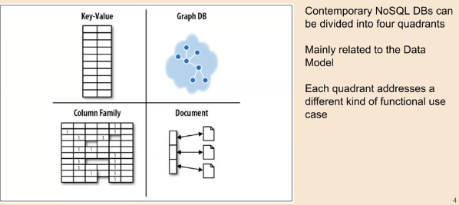
* Types of NoSQL DB by data model
  + 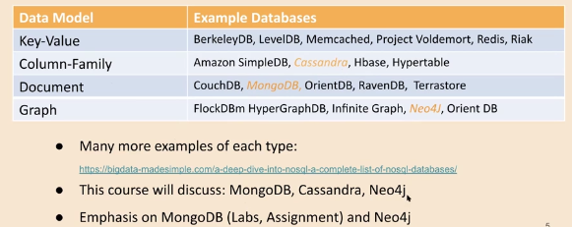
* Key-Value Model
  + Most basic type of non-relational databases
  + Items stored as an attribute name (key) with its value: <key, value>
  + Data can only be queried by the key (value is opaque)
  + Key-value pairs, are well established concept in many programming languages (Associative arrays, dictionary, hash)
  + Single means of accessing data, does not allow complex queries, scales very well
  + Very fast
* Key-value model applications
  + General web/computers
  + E-commerce
  + Networking/data maintenance
  + Who’s using redis
* Column models (Column family)
  + Store data in column-oriented manner
  + Use concept called a keyspace (~schema)
  + Keyspace contains all the column families (~ tables in the relational model), which contain rows, which contain columns
  + Each row can contain a different number of (potentially different) columns to the other rows
  + Good for big data – compression, aggregation queries, scalability, speed..
* Column model applications
  + Google Cloud Bigtable
  + Cassandra
* Document Model
  + Store data in documents
  + Ddocuments use a structure like JSON (JavaScript Object Notation)
  + Closely aligned with OO programming (each document is an object)
  + Documents
    - Contain one or more fields
    - Each field contains a typed value (String, data, binary, decimal, array)
    - Hierarchical – each record and its assoc. data stored in single document (rather than spread across multiple foreign key linked tables)
  + Notion of schema is dynamic – each doc can contain diff. fields
  + Data can be queried based on combo of fields in a document
* Document Model applications
  + General purpose – useful for wide range of applications
  + Companies – Bank, insurance, Telefonic, Media, Oil, Clothing, Games
  + Government – revenues, weather forecast, etc.
* Graph Model
  + Relationships are explicitly embedded in a graph data model
  + Graphs foundationally designed to express relatedness
  + More concerned with relationships (edges) than entities (vertexes)
    - Nodes – entities
    - Edges – relationships between entities
  + Graph model applications
    - AI and machine learning
    - IoT
    - Master Data Management
    - Fraud detection
    - Network/IT operations
  + Data Model Continuum
    - 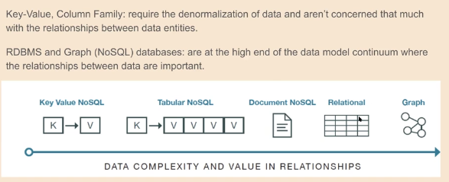
* Summary

## Introduction to MongoDB

* Document Database
  + Record in MongoDB is a document, similar to JSON objects
  + Data structure composed of field and value pairs
  + Values of fields may include other documents, arrays, and arrays of documents
  + 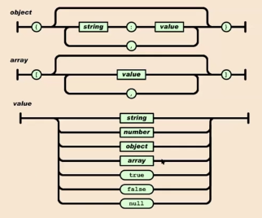
* BSON (short for Binary JSON)
  + MongoDB stores data records as BSON docs
  + BSON is a binary representation of JSON docs, though it contains more data types than JSON
  + For example, BSON has a Date type and a BinData type
  + Like JSON, BSON supports the embedding of docs and arrays within other docs and arrays
* Document Structure
  + MongoDB documents are composed of field-and-value pairs
    - Value of a field can be any of the BSON data types, including other documents, arrays, and arrays of documents
    - 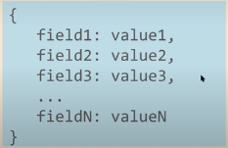
* Example
  + 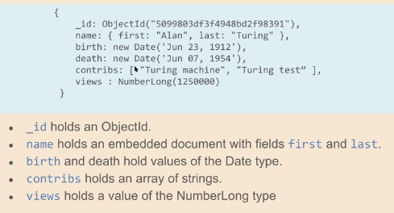
* Primary Key: _id field
  + Each document requires unique _id field that acts as primary key
  + If inserted document omits the _id field, MongoDB automatically generates an ObjectId
  + ObjectID: 12 bytes, where first 4 bytes are a timestamp of the ObjectID’s creation, specifically:
    - 4-byte value representing seconds since Unix epoch
    - 5-byte random value
    - 3-byte counter, starting with random value
* Databases and collections
  + BSON documents are stored in collections, which are analogous to Tables in RD
  + Collections are stored in databases
* Mongo Shell
  + Interactive JavaScript shell interface to MongoDb
  + Allows us to manipultaate databases, collections and documents
  + Powerful interface to test queries and operations
  + Provides a fully functional JavaScript environment
  + User account on MongoDB server at the University
  + For practical 1, we will use a web interface to MongoDB
* Query Language
  + Rich query language to support CRUD operations
    - Create (insert) operations
    - Read operations
    - Update
    - Delete
  + Dot notation used to access fields of documents, embedded documents and elements of arrays
  + Data aggregation
  + Text search and geospatial queries
* Create databases
  + To select an existing database to use, in the mongo shell
    - Use myDB
    - If a database does not exist, MongoDB creates it when you first store data for that database
    - In this module, we will not create a database, instead we will use the provided default dataset and ass collections to it
* Create collections
  + MongoDB stores documents in collections, which are analogous to tables in RD
  + Db.createCollection() method explicitly creates a collection with various options (max size, validation rules)
  + If collection does not exist, MongoDB creates the collection when you first store data for that collection
* Insert operations
  + 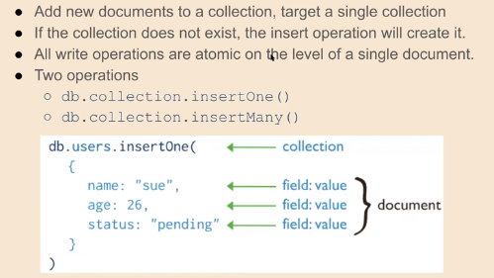
  + 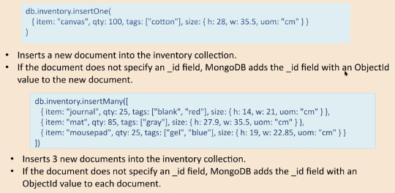
* Read operations (Queries)
  + 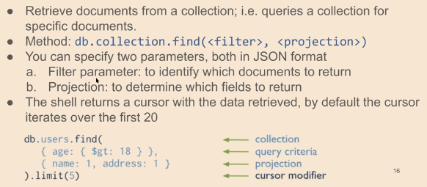
* Read operations: filter parameter
  + 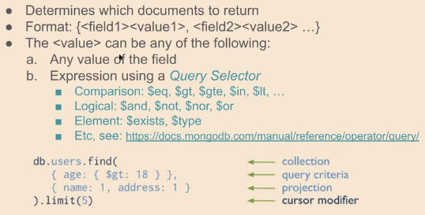
* Read Operations: The Projection Parameter
  + 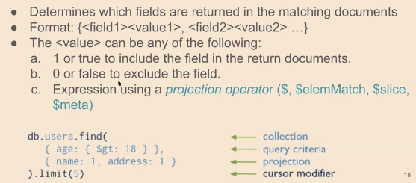
* Queries – Examples
  + 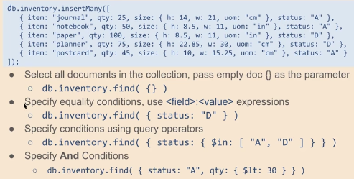
* Update Operators
  + 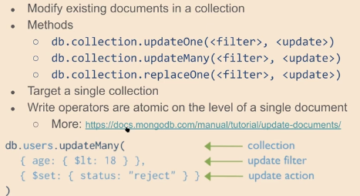
* Delete Operators
  + 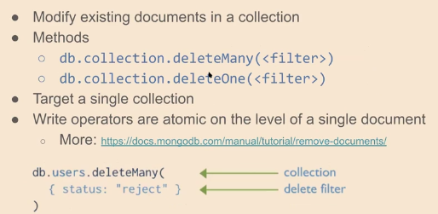
* Summary
  + Introduced MongoDB
  + Structure of Documents (JSON, BSON)
  + Databases and collections
  + Mongo Shell
  + Query Language & CRUD operations

# Week 2

## Cursors and Projections in MongoDB

* Cursors
  + The db.collection.find() method returns a cursor.
  + A cursor is a ‘pointer’ to the results.
  + To access the documents, need to iterate the cursor
  + If returned cursor is not assigned to a variable then the cursor is automatically iterated up to 20 times (print up to the first 20 documents in the result), you can type “it” to continue seeing results
  + MongoDB shell has JS interpreter
  + Can ssign result of the query to a variable using var keyword
  + To access full set of results, have two ways
    - Iterate cursor manually
    - Use iterator index
* Example – inventory data
  + 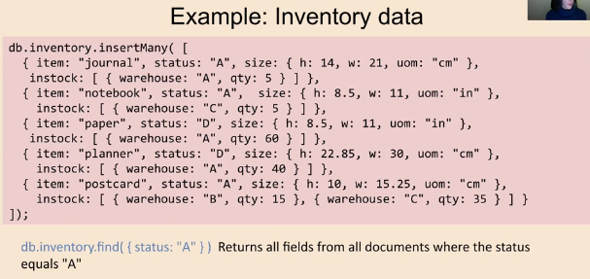
* Manually iterate cursor
  + 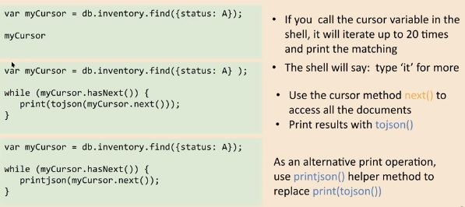
* Iterator index
  + Can use the toArray() method to iterate cursor and return documents in an array
  + The toArray() method
    - Loads into RAM all documents returned by the cursor
    - Exhausts the cursor
    - 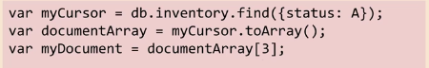
* Projections
  + By default, queries in MongoDB return all fields in matching docs
  + To limit amount of data, can include projection doc to specify or restrict fields to return
* Return specified fields
  + Projection can explicitly include several fields by setting the <field> to 1 in the projection document
  + _id field shown by default
  + 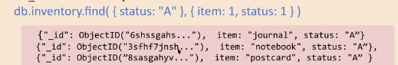
  + Can suppress _id field by setting it to 0 in the projection
  + 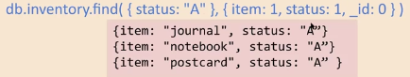
* Return all but excluded fields
  + Can use projection to exclude specific fields
  + Notice that with exception of _id field, cannot combine inclusion and exclusion statements in projection documents
  + 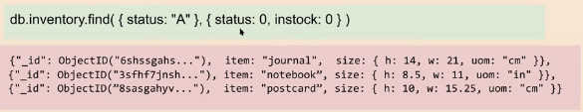
* Return specific fields in embedded document
  + Can return specific fields in an embedded document
  + Use dot notation to refer to the embedded field and set to 1 in the projection document – enclose embedded field in “”
  + 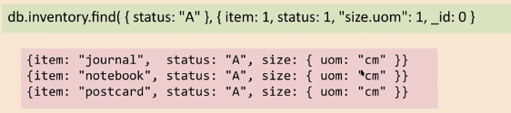
  + To suppress – set to 0
  + Use dot notation to refer to embedded field and set to 0 in projection doc
* Projection on embedded docs in array
  + Use dot notation to project specific fields inside documents embedded in an array (use “”)
  + 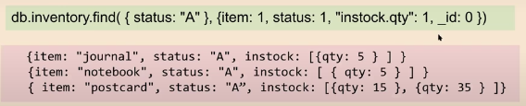
* Project specific array elements in the returned array
  + MongoDB provides projection operators for manipulating arrays:
    - $slice – controls no items of an array that a query returns
    - 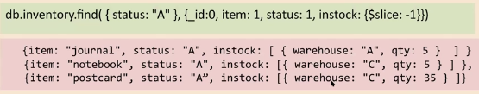
    - $elemMatch – limits contents of n <array> field from the query results to contain only the first element matching the $elemMatch condition
    - 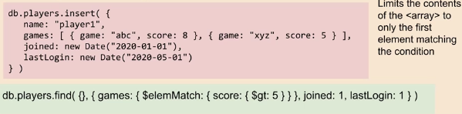
  + Cannot project specific array elements using the array index; e.g. {“instock.0”: 1} does not work
* Summary cursors and projections
  + Cursors
    - Db.collection.find() method returns a cursors
    - To access whole set of results, need to
      * Iterate cursor manually
      * Use iterator index, converting cursor into an array
  + Projections, 2nd parameter of .find() function
    - Specify or restrict fields to return from a query
    - Return or suppress specified fields
    - Return or suppress specific fields in embedded documents
    - Project embedded documents in an array
    - Project specific array elements in the returned array

## Aggregation in MongoDB

* Aggregation framework
  + Is another way of querying data in MongoDB, but can do much more
* Data aggregation
  + Process in which info is gathered and expressed in a summary form for stat analysis
  + Aggregation operations
    - Group values from multiple docs together
    - Perform variety of operations on the grouped data to return required results
* Aggregation in MongoDB
  + 3 main ways to perform:
    - Aggregation pipeline
      * Preferred, use native code
      * More efficient than map-reduce
    - Single purpose aggregation methods
      * Limited scope
      * Easy to program common aggregations
    - Map-reduce function
      * Harder to program, can be more flexible
      * Less efficient, uses custom JS functions
  + 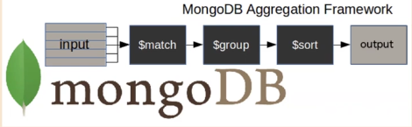
  + Consists of stages
  + Each stage transforms documents
  + Pipeline stages do not need to produce one output doc for every input doc; e/g/ some stages may generate new documents or filter out documents
  + Pipeline stages can appear multiple times in the pipeline
* Syntax and structure
  + 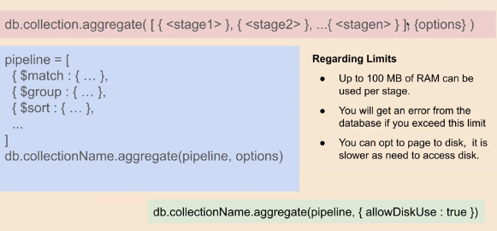
* Some common stages
  + $match – filter collection according to query parameters, only pass through the docs matching the query, to the next stage of the pipeline
  + $group – groups docs by some specified expression and outputs to the next stage a document for each distinct grouping
  + $project – reshapes each doc in the stream, such as by adding new fields or removing existing field – for each input doc, outputs one doc
  + $unwind – operates on arrays – deconstructs array field from the input documents to output a document for each element
  + $sort – reorders the doc stream by a specified sort key – only order changes, docs unmodified
* $match
  + Should be placed early in pipeline, as it limits the no of docs, thus optimising process
  + 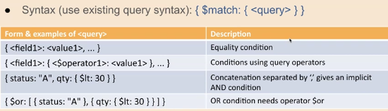
  + 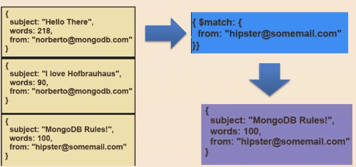
  + 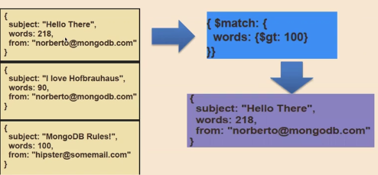
* $project
  + 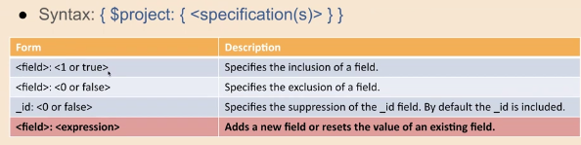
  + 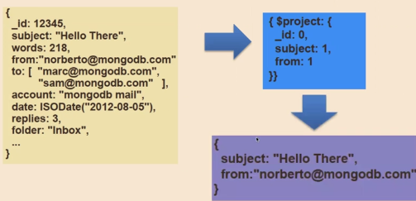
  + 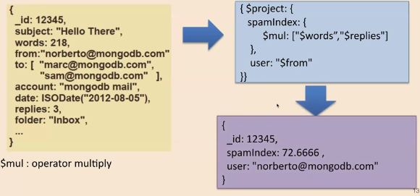
  + 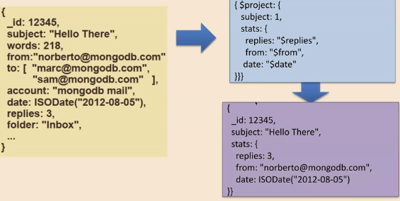
  + Note with 2 and 3 we are reshaping the document
* $group
  + Requires _id field to specify what incoming docs should be grouped on
  + Output docs contain
  + _id field with distinct groups
  + Computed fields that hold the values of some accumulator expression grouped by the group’s _id field
    - $max, $min, $avg, $sum
    - $addToSet, $push
    - $first, $last
  + $group syntax
    - 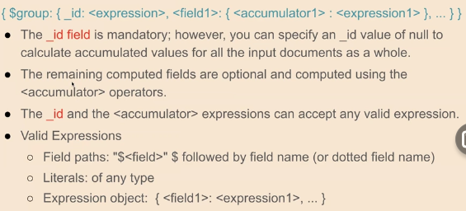
  + Example – calculating an average: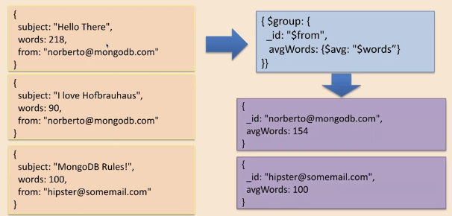
  + Example – summing fields and counting

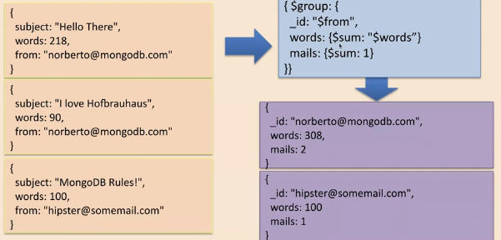

* $sort
  + Sorts all input documents and returns them to the pipeline in sorted
  + Syntax:
    - 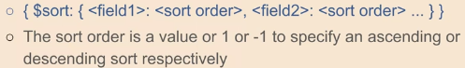
  + 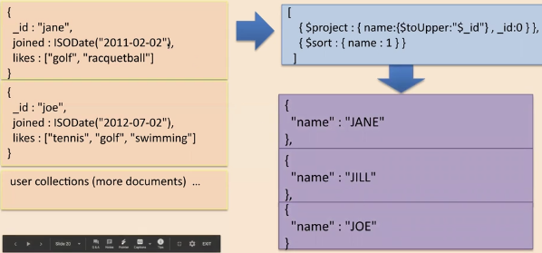
* $unwind
  + Operates on array field
  + Deconstructs array from input docs
  + Creates an output doc for each array element
  + Syntax: { $unwind: <field> }
    - <field> is a string “$<field_name>”
  + 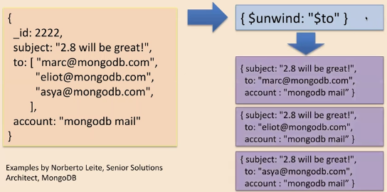
* Single purpose aggregation operations
  + MongoDB also provides operations for common aggregations
    - db.collection.count(query, options): Returns the count of documents that would match a find() query for the collection or view
    - db.collection.distinct(field, query, options): reutns an array with the distinct values for a specified field across a single collection
  + Provide simple access to common aggregation processes, they lack the flexibilities and capabilities of the aggregation pipeline and map-reduce
  + Example

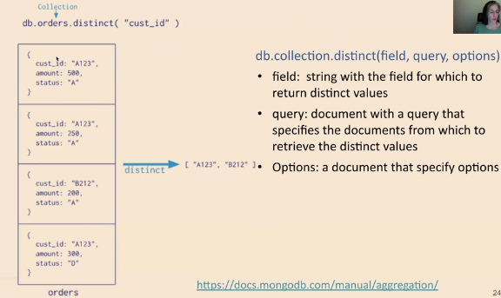

* Aggregation summary
  + Series of doc transformation, concatenated stages
  + MongoDB provides three ways to perform aggregation
    - Aggregation pipeline
      * Preferred method, use native code
      * More efficient than map-reduce
    - Single purpose aggregation methods
      * Limited scope
      * Easy to program common aggregations
    - Map-reduce function (not covered in module)
      * Harder to program, can be more flexible
      * Less efficient, uses custom JS functions

## Indexes in MongoDB

* Indexes
  + Needed to improve efficiency of read (query) operations
  + Without indexes, each doc in a collection must be scanned to select those that match the query statement
  + Defined at collection level
  + Supported on any field or subfield of the documents
* What are indexes?
  + Special data structures that store a small portion of the collection’s data set in an easy to traverse form
  + Kept in memory
  + Index stores the value of a specific field or set of fields, ordered by the value of the field
  + Ordering supports efficient equality matches and range-based query operations
  + Sorted results can be returned
  + Like index in book
* Example of single field index
  + 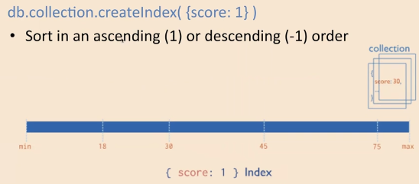
* Index structure
  + Uses B-trees, common DB index structures
  + 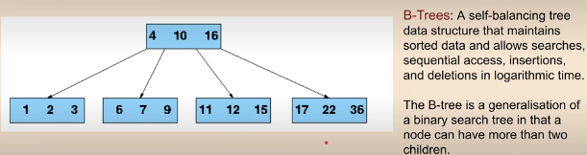
  + B-trees maintain sorted data
  + Search, insert and delete are all possible in O(log n) time
* Why indexing
  + Searching every record is O(n)
  + Searching B-Tree index is O(log n)
  + Other benefits
    - Results already sorted without need for additional sort operation after a query
    - Covered results don’t need DB access at all, just return the data from the index (e.g. Count the scores over 30) if the score field has an index
    - Range search easy
* Index syntax

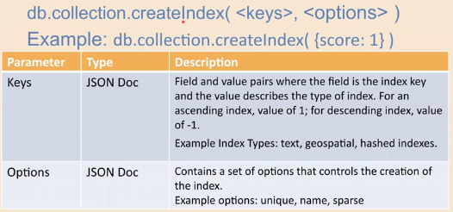

* Basic index types
  + Default_id – the ID given to each field by MongoDB is indexed by default
  + Single field – User defined indexes on single fields, e.g. username
  + Compound index – sorts first by one index, then by the next etc. Useful if values are duplicated or coverage needed across more than one field
* Single field index

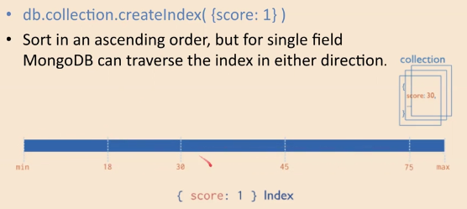

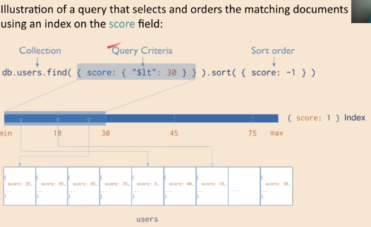

* Compound index

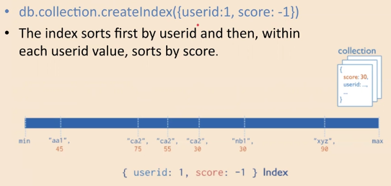

* Other types of indexes
  + Multikey – to index content stored in arrays
  + Geospatial – to support efficient queries of geospatial coordinate data
  + Text – text searchers over fields in your documents
  + Hashed – indexes the hash of a field to support hash-based sharding
* Index properties (options)
  + Unique indexes – reject duplicate values for the index field
  + Sparse indexes – only index entries that have the index field, so only contain a subset of the whole collection
  + Parial indexes – only index the documents in a collection that meet a specified filter expression. They have lower storage requirements and reduced performance costsfor index creation and maintenance
* Example – text index search

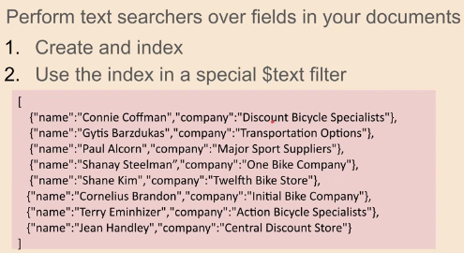

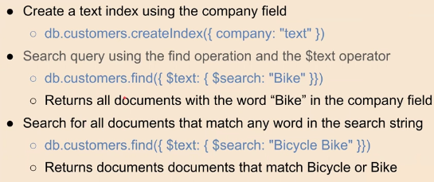

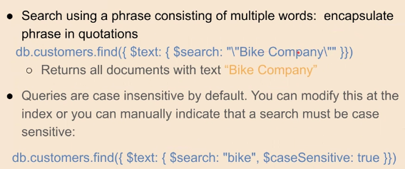

* Choosing indexes
  + Think about common queries
    - Compound indexes speed queries across multiple fields
  + Indexes are stored in RAM for speed
  + Don’t build so many that RAM filled
  + Indexes can slow down writes as the index needs to be altered too, so only index what is needed
* Summary
  + Indexes can improve efficiency of read (query) operation
  + Mongo DB provides several types
    - Default_id
    - Single field
    - Compound index
    - Multikey, Geospatial, Hashed
  + db.collection.createIndex(<keys>,<options>)

# Week 3

## Data Modelling in MongoDB

* What is data modeeling
  + Way to organise fields in a doc to supp app performance and querying capabilities
  + Rule of thumb – data should be stored in the way it is used
* Two forms of modelling relationships in MongoDB
  + Referenced documents
  + Embedded documents
* Document structure – how to represent relationship between the data
  + Embedded documents
    - Store relationships by storing related data in a single document
    - Documents and arrays can be embedded within a document
    - Denormalised data models
    - Related data can be retrieved and manipulated in a single operation
    - 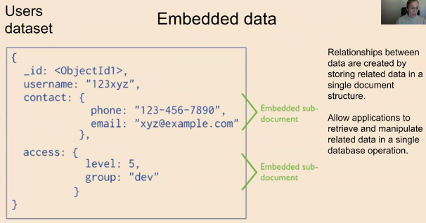
  + Referenced documents
    - Store the relationships by including links or references from one document to another
    - Applications need to resolve these references to access the related data
    - Normalised data models
    - More than one op needed to access data
    - 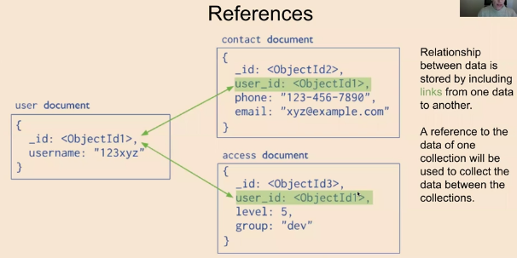
* Advantage of embedded data models
  + Allow apps to store related pieces of info in the same doc
  + Apps may need to issue fewer queries and updates to complete common ops
  + Provides better performance as related data can be read or updated in a single operation
* Use embedded models when you have
  + One-to-one (“contains”) relationships between entities
  + One-to-many relationships between entities and the “many” or child documents always appear with or are viewed in the context of the “one” or parent docs
  + Sub-docs are small in size
* Example users dataset
  + 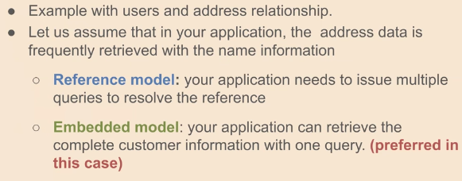
  + 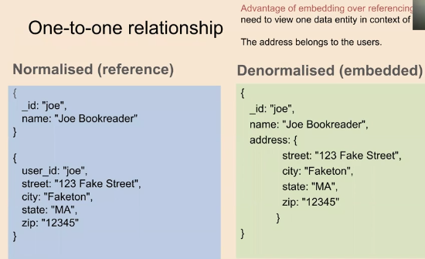
  + 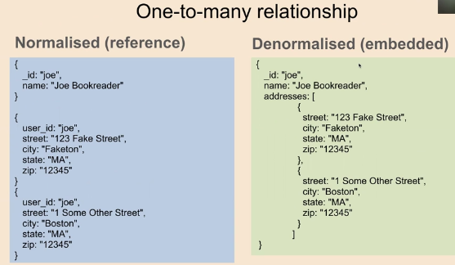
* Normalised data models
  + References provides more flexibility than embedding
  + However, client-side apps must issue follow-up queries to resolve the references
  + In other words, normalised data models can require more round trips to server
* Sometimes normalised models better
  + Sub-docs that continuously increase in size (one-to-many) but the “many” grows
  + Ver large sub-document information (16 MB is mongoDB limit) (normalised models avoid duplication)
  + To represent many-to-many relationships
  + To model large hierarchical data sets
* One-to-many relationships w/ references
  + 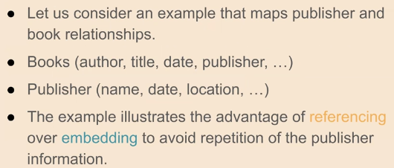
  + 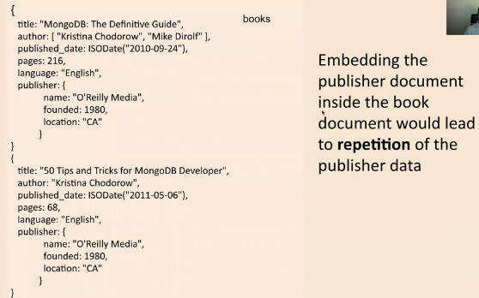
  + 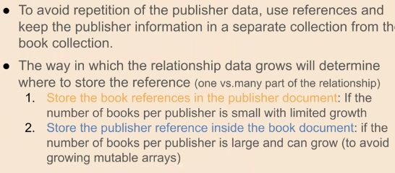
  + 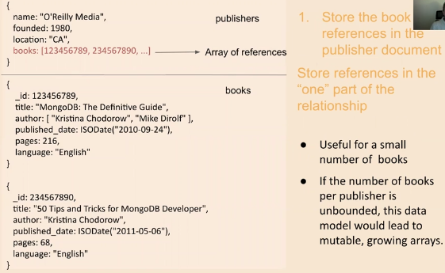
  + 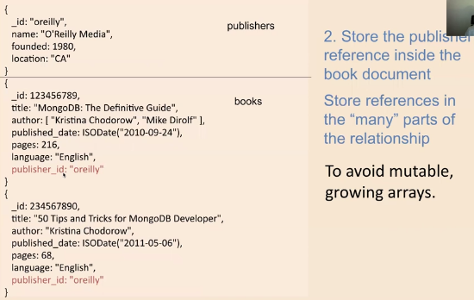
* Some considerations when modelling data
  + Data usage
    - How the apps will access the database?
    - What will be the pattern of data, such as reading, writing, updating, and deletion of data?
    - Some apps are read centric and some are write-centric
    - It may be that some data is used/updated frequently whereas some data is completely static
  + Document growth
    - Some updates increase document size
    - While using embedded docs, must analyse if the sub-object can grow further out of bounds
    - Otherwise, there may occur performance degradation when the size of the doc crosses its limit
  + Summary
    - When designing data models we should consider the structure and usage of the data (queries, updates)
    - Embedded
      * Related pieces of info stored in the same document
      * Preferred for one-to-one relationships, or one-to-many when the “many” are always viewed in the context of the “one” (and sub-documents are small)
      * Fewer queries required to complete an operation
    - References
      * Related pieces of information stored in different documents
      * Preferred when sub-documents are very large or increase in size
      * To model many-many relationships
      * More queries required to complete operation

## Replication in MongoDB

* Main factor for NoSQL – Clusters
  + Increase in scale (what is now big data), produced a need of more computing resources
  + Two options
    - Scaling up
    - Scaling out
  + RDB not designed to run efficiently on clusters, while NoSQL have been designed to run on clusters
* Terminology
  + Node – computer that offers processing, local storage, and it is connected to other nodes
  + Cluster – set of connected nodes that work together, in some ways they can be seen as a single system – each node performs similar tasks
  + Located on particular rack on a data centre, geographically distributed
* Concepts of distributed databased
  + Replpication
    - Copies same data across multiple servers
    - Same data can be found in multiple places
    - Synchronous (relational) or asynchronous (NoSQL)
  + Sharding
    - Distributes different data across multiple servers
    - Each server acts as the single source for a subset of data
  + MongoDB combines replication with sharding
* Replication
  + 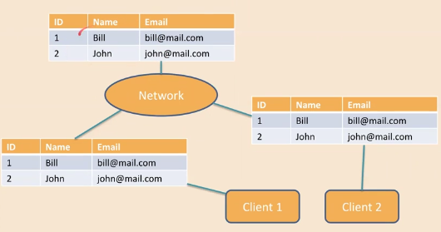
  + Why replication?
    - Avoids data loss
    - High availability of data
    - Disaster recovery
    - No downtime for maintenance (backups, index rebuilds, compaction)
    - Increased performance – reduce data distance by accessing local replica
  + Types of replication
    - Synchronous – relational DB
      * All replicas are updated on every write
      * Reads guaranteed to be up to date, so can read from any node
      * Maintains benefit of resilience, but can be too slow for some apps
      * Used if reads MUST be up to date
      * Works best if fewer writes made
    - Asynchronous – NoSQL DBs
      * Writes propagated as soon as possible, but reads do not have to wait
      * Reads can be out of date
      * Eventual consistency
      * Used if reads can be a little out of date
      * Methods include
        + Primary-secondary (master-slave)
        + Replica set
        + Peer-to-peer
* Replication in MongoDB
  + MongoDB achieves replication by use of replica set
  + Replica set – group of >-2 nodes that host the same data
  + In replica set, one node primary, the remaining are secondary
  + Primary node receives all write operations from clients
  + All data replicated from primary to secondary nodes; so all nodes (eventually) have the same data
  + Secondaries can be read but not written to
  + Replica sets in MongoDB
    - 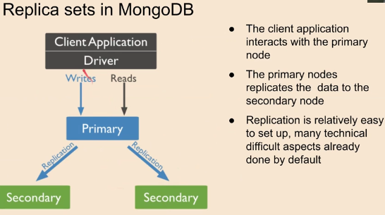
  + Read preference
    - 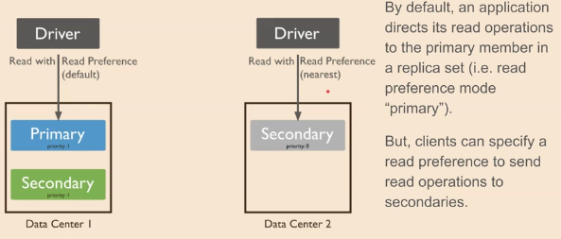
  + Automatic failover – feature of replica set
    - If primary fails or becomes unavailable, one of replicas will be elected as the replacement
    - Fails or unavailable – will trigger automatic failover process
    - Election process is sophisticated and is a built-in element of MongoDB
    - 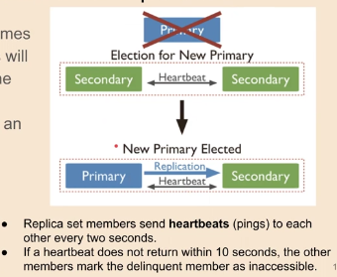
* Consistency
  + In relational DB, ACID consistency is handled by transactions, which maintain DB integrity
  + In NoSQL, consistency refers to whether or not reads reflect previous writes
    - Strict consistency – read guaranteed to get the most up to date data
    - Eventual consistency – read data may be stale but writes will catch up pretty quick
* More on replication in MongoDB
  + Always reading from primary gives strict consistency
  + Reads from secondary may be stale, so this is eventual consistency
  + Why use eventual?
    - For performance, reads can be spread across multiple secondary nodes
    - Some apps like facebook don’t need strict consistency
    - Offline analytics should read from secondaries to avoid overloading primary
* Summary of replication
  + Copies data across multiple servers
  + Each data can be found in multiple places
  + MongoDB uses replica sets (Asynchronous)
  + Replica sets provide redundancy and high availability
  + 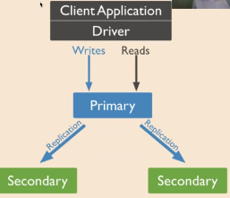
  + A replica set in MongoDb is a group of mongod processes that maintain the same data set

## Sharding in MongoDB

* Sharding
  + Practice of distributing data across multiple machines
  + Each node has a subset of the data
  + Supports for big datasets
  + Might split data by location (UK customer centre in Ireland, American customer data in NY)
  + Workload can be evenly shared, this can improve efficiency over having a single server
  + 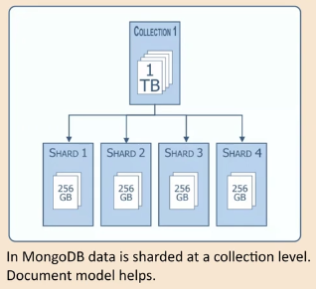
* Combining sharding with replication
  + 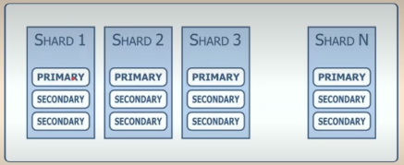
  + Each cluster kees a replica set w/ primary and secondary servers
  + Replica set is group of instances that maintain same data set
* Architecture of a sharded cluster
  + Three components
    - Shards – used to store the data
    - Config servers – clusters metadata, mapping of the clusters’ data to the shards
    - Query routers – provides interface between client apps and the sharded cluster
    - 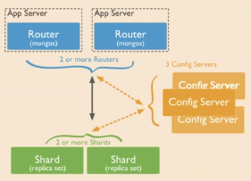
* Shard keys
  + Used to distribute collection’s documents across shards
  + Consists of a field(s) that exist in every document in the target collection; field(s) need to be an index in collection
  + Once selected it can’t be changed
  + Choice of shard key affects performance, efficiency and scalability of sharded cluster
  + Two main types of shard keys – ranged-based and hash-based
* Range-based shard keys
  + Divides the data set into ranges determined by the shard key values to provide
  + Numeric key – if you visualise a line that goes from -infinity to +infinity each value of the shard key falls at some point on the line
  + Line can be divided into smaller non-overlapping ranges called chunks where a chunk is a range of values with some min val to some max val
  + Documents with “close” shard key values are likely to be in the same chunk and therefore on the same shard
  + 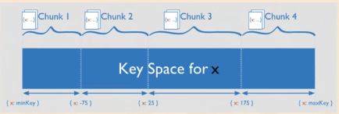
* Selecting shard key
  + 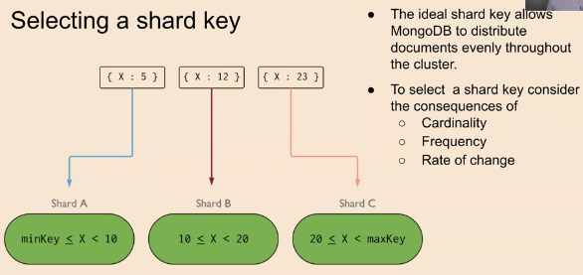
* Cardinality
  + 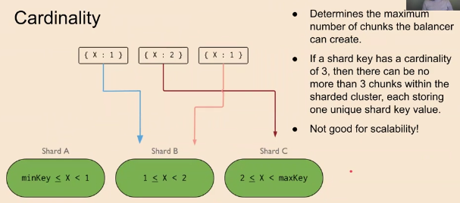
* Frequency
  + 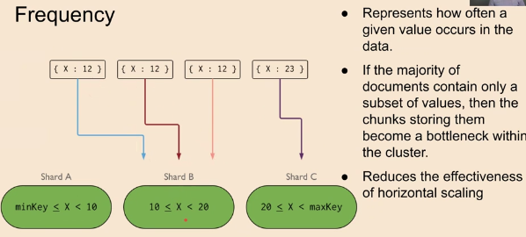
* Monotonically changing shard keys
  + 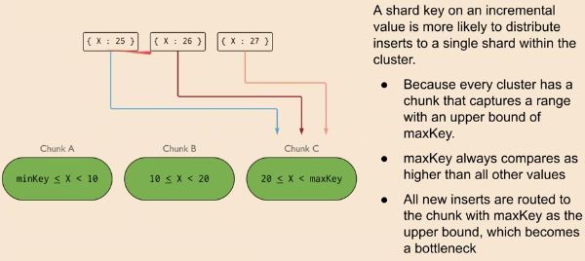
* What makes a good shard key?
  + High cardinality – lots of unique possible values
  + Low frequency – little repetition of those unique values
  + Non-monotonically changing – non-linear change in values
* Hash-based shard keys
  + If data model requires sharding on key that changes monotonically, consider using hashed sharding
  + MongoDB computes hash of a field’s value, and then uses these hashes to create chunks (hash based partitioning)
  + Two documents with close shard key values are unlikely to be part of the same chunk
  + Ensures a more even distribution of a collection in the cluster
* Hashed vs ranged sharding
  + 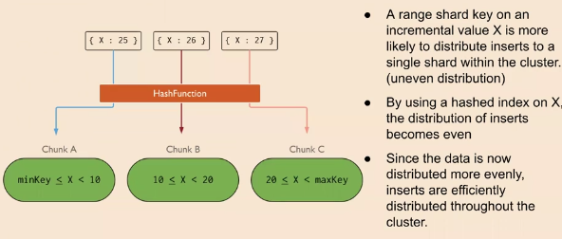
* Summary
  + Sharding
    - Distributes diff data across multiple servers
    - Each server acts as single source for subset of data
    - Shard keys important for efficiency and scalability
  + Shard keys
    - Consists of field(s) that exist in every doc in the target collection – the field(s) need to be an index in the collection
    - Consideration – cardinality, frequency, rate of change
    - Two main types – ranged-based and hash-based

# Week 4

## Intro to Column-Family Databases

* The NoSQL Quadrants
  + Contemp. NoSQL DBs can be divided into four quadrants
  + Mainly related to the Data Model
  + Each quadrant addresses a diff. kind of functional use case
  + 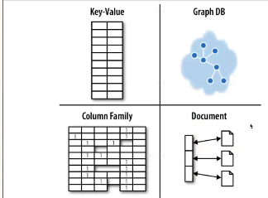
  + 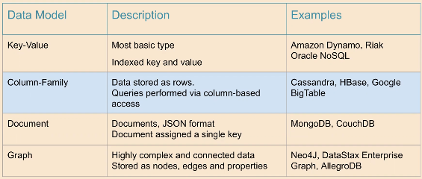
* Benefits of columnar databases
  + Compression – v. efficient at data compression and/or partitioning
  + Aggregation queries – due to their structure, perform particularly well w/ aggregation queries (such as SUM, COUNT, AVG, etc)
  + Scalability – well suited to massively parallel processing, which involves having data spread across large cluster of machines
  + Fast to load and query – can be loaded v. fast; a billion row table could be loaded in a few seconds
* Cassandra
  + Powerful open source distributed database system that works well to handle large volumes of records spread across multiple commodity servers
  + Highly consistent, fault-tolerant, scalable
* Cassandra Charcateristics
  + Data model – column families
  + Architecture – distributed, scale-out, “masterless” (i.e. there is no ‘master’ node)
  + Data distribution – distributes data evenly to all nodes making up a database cluster and enables both reads & writes on all machines
  + Availability model – since Cassandra is masterlss, provides redundancy of both data and function on each node so it offers continuous availability w/ no downtime
  + Scaling and performance model – scales horizon. By adding extra nodes that deliver increases scale and performance in linear manner
* Cassandra data model
  + In traditional, relational database, every column must be satisfied to store a row
  + Within a table, each row may or may not have relevant data for each column
  + 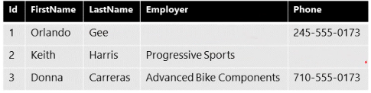
  + In Cassandra, each row w/in table essentially has its own set of columns
  + 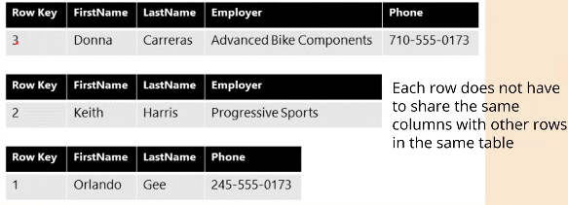
  + Each key in Cassandra directly points to specific “row” in the table
  + Each row points to collection of columns
  + 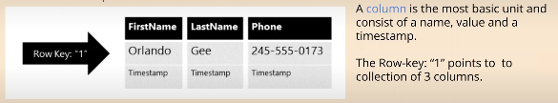
  + Cassandra can store individual columns in a distributed manner to optimise for specific queries
  + Columns that are often queried together can be placed on the same node to optimise the performance of the specific query
* Column families
  + Conceptually, we still have “Tables”, but they can be distributed across nodes
  + Row key to identify each row
  + Columns are flexible can vary from row to row
  + If row does not contain value for certain column, that column is simply missing
  + Variable length lists of unique values, saves lots of space
  + 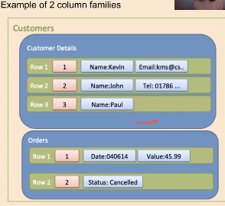
* Summary
  + Origins and motivation of column-family databases
  + Relational DBs vs Column-family DBs
  + Cassandra data model

## Cassandra Query Language And Use Cases

* Queries in Cassandra
  + Own query language named Cassandra Query Language (CQL)
  + Can use Cassandra query shell (cqlsh) to interact w/ Cassandra and issue queries directly against database
  + Many of TABLE, INSERT, and SELECT queries are the same between SQL and Cassandra
  + CQL has many features for querying data, but not all that SQL has
  + CQL does not allow joins or subqueries, and WHERE clauses are simple
* Creating a database
  + 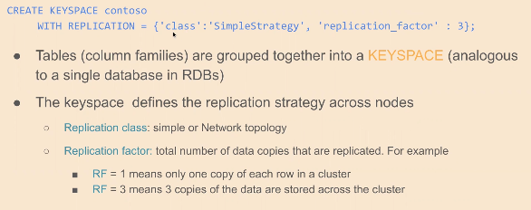
* Create a table
  + Use existing database and then use CREATE TABLE command
  + 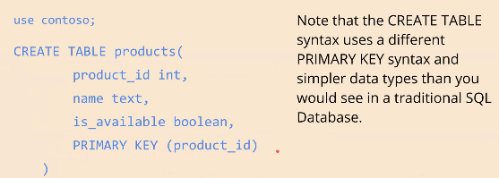
* SELECT
  + 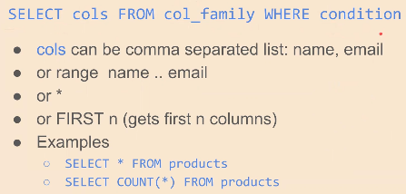
* INSERT
  + 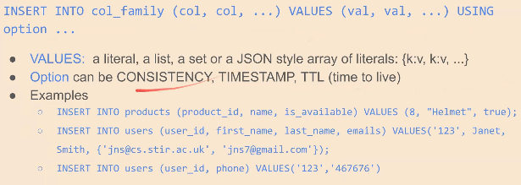
* Use cases
  + Cloud apps – apps that require wide distribution of data, no downtime, predictable performance…
  + IOT – consuming and analysisng lots of fast-incoming data from devices, sensors, similar mechanisms…
  + Product catalogs
  + User activity tracking and monitoring
  + Messaging – Cassandra serves as database backbone for numerous mobile phone, telecom, cable/wireless, and messaging providers’ applications
  + Social media analytics and recommendation engines
  + Other time series based apps
* Summary
  + Cassandra
  + Query Language
  + Use cases

## Cassandra Architecture

* Distributed databases: CAP theorem
  + States that no distributed system can simultaneously guarantee
    - Consistency
    - Availability
    - Partition-Tolerance
  + Cassandra chooses to be “AP”, meaning it provides Availability and Partition-Tolerance at the expense of consistency; Pa-To often cannot be traded off.
  + 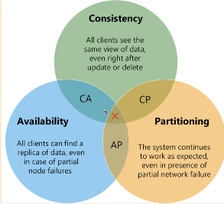
* CAP theorem
  + Consistency
    - All nodes see same data at same time
    - Performing a read operation will return the value of the most recent write operation causing all nodes to return the same data
  + Availability
    - Every client gets a response, regardless of the state of any individual node in the system (success/failure)
    - Requires that system remains operational 100% of the time
  + Partition-Tolerance
    - System continues to run, despite number of messages being delayed by the network between nodes
    - System can sustain any amount of network failure
* Trade off consistency vs availability
  + Generally, we need distributed DB that is Partition Tolerant
  + Can only do that by losing either consistency or availability
    - Can keep consistent by making some nodes unavailable (CP)
    - Or stay available but accept that it will become inconsistent (AP)
  + Relational database system is CA
* Cassandra architecture
  + Database can scale and perform with no downtime (continuous availability)
  + Masterless (peer-to-peer) “ring” distributed architecture
  + To add more capacity, simply add new nodes in an online fashion to existing cluster
  + No single point of failure, true continuous availability and uptime
  + 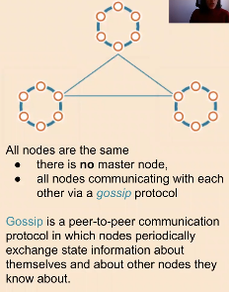
* Cassandra is distributed and decentralised
  + Distributed – capable of running on multiple machines
  + Decentralised – no single point of failure
  + Single cluster may run across geographically dispersed data centers
  + 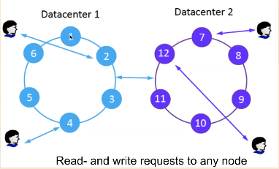
* Automatic partition
  + Cass. Automatically distributes and maintains data across nodes in cluster
  + Uses a partitioner, a hashing mechanism that takes a table row’s primary key, computes a numerical token for it, and assigns it to one of the nodes in a cluster
  + Two main strategies for partitioning
    - Random partitioning – default and recommended strategy
    - Ordered partitioning – stores column family row keys in sorted order across the nodes in a DD cluster
  + 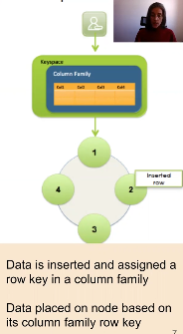
* Replication
  + Controlled by two parameters
    - Replication factor – total no of data copies that are replicated
    - Replication strategy
      * Simple – places original row on a node determined by the partitioner
        + Additional replica rows placed on the next nodes clockwise in the ring without considering rack or data centre location
        + 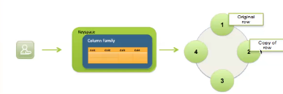
      * Network topology – allows for replication between different racks in a data centre and/or between multiple data centres
        + This strategy provides more control over where replica rows are placed
        + 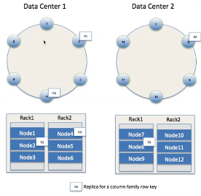
* Elastic scalability
  + Scales horizontally, adding more machines
  + Adding nodes increase performance throughput (transactions/secs) linearly
  + Adding or removing nords, happens seamlessly (auto distribution and maintenance)
  + 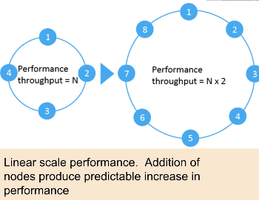
* Turnable data consistency
  + Supports transactions with strong or eventual consistency
  + Adjustable for read-and-write operations separately
  + Conflicts solved during reads, focus lies on write performance
  + 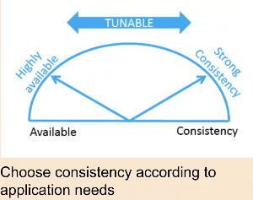
* Summary
  + CAP Theorem – no distributed system can simultaneously guarantee
    - Consistency
    - Availability
    - Partition-tolerance
  + Casandra
    - Architecture
    - Data distribution (partition)
    - Data replication
    - Other features – elastic scalability, turnable consistency

# Week 5

## Intro to Graphs and Networks

* What is a network?
  + A collection points that are connected with lines
  + A graph is an ordered pair G = (V, E), where V set of vertices, E set of edges (2-element subsets of V)
  + **Graph**: mathematical abstraction
  + **Network**: real-world data-driven instantiation
  + 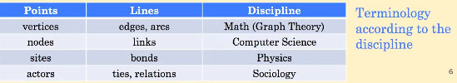
* Types of networks
  + 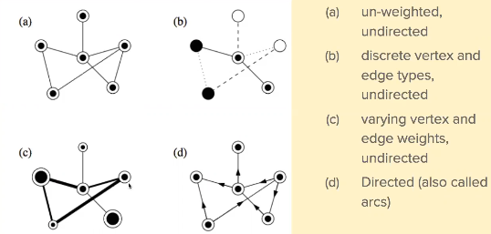
* Complex network
  + Have nontrivial topological features, i.e., its structure is irregular as opposed to regular/simple
  + Are not random either
  + Can evolve over time
  + Examples
    - Technological networks
      * Internet, WWW, telephone, railway, airlines…
    - Biological networks
      * Neural networks, metabolic networks, food web, protein interaction networks…
    - Social networks
      * Friendships, scientific collaborations..
* Network metrics
  + 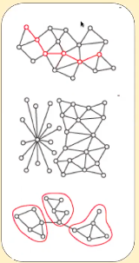
  + Distance
    - Number of links that make up the path between two points
    - Diameter, average shortest path
  + Topology
    - Gives idea of the spread in the number of links the nodes have
    - P(k) is the probability that a randomly selected node has k links
  + Cohesion or clustering
    - Cliques in social network
    - Clustering coefficient
    - Community structure
* Diameter and shortest path
  + Shortest path: path between two nodes that visits the fewest intermediate nodes (path with less edges)
  + 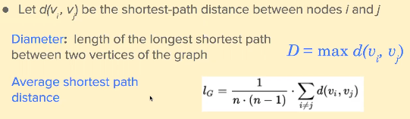
* Degree and degree distribution
  + Degree of vertex I – number of edges incident on i
  + Degree distribution – probability distribution of these degrees over whole network
  + 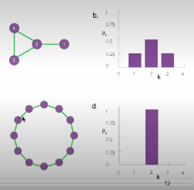
* Poisson vs. Power-law distributions
  + Random network
    - Poisson distribution
    - Most nodes have comparable degrees
    - No nodes with large number of links
    - Highway network
  + Many real-world networks
    - Power-law distribution
    - Most nodes have only a few links
    - Hubs – few lightly connected nodes
    - Air-traffic network
  + 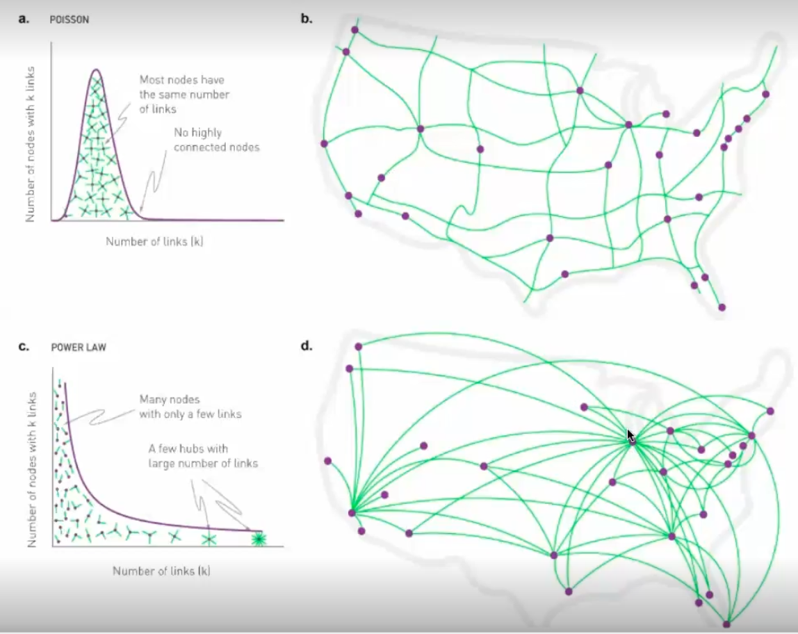
* Community structure
  + Communities are locally dense connected subgraphs in a network; this expectation relies on two distinct hypotheses:
    - Connectedness hypothesis – each commun. corresponds to a connected subgraph
    - Density hypothesis – nodes in community more likely to connect to other members of same community than to nodes in other comms.
  + 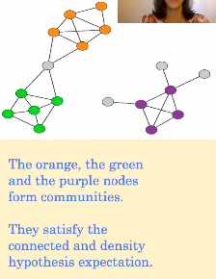
* Network visualisation
  + Graphs are abstract mathematical structures
  + They do not have a unique visual representation
  + Graph visualisation: art of choosing an appropriate representation that is aesthetically pleasing and highlights important structural properties
  + 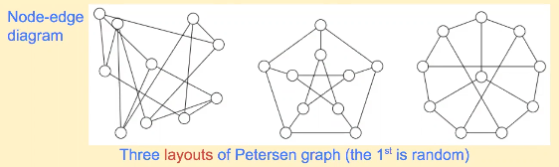
* Force-directed graph layout algorithms
  + Based on physical analogy of electricity and springs
  + Strive to satisfy accepted aesthetic criteria
    - Vertices distributed roughly evenly on the plane
    - Number of edge crossings is minimised
    - Lengths of edges approx. uniform
    - Inherent symmetries in graph respected
  + 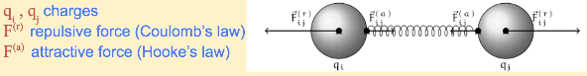
  + Fruchterman-Reingold (standard)
    - Simulates system for number of steps
    - Constraints displacements of nodes from large to small, gradually
    - Stops when displacement is smaller than given threshold
  + Kamada-Kawai (organic)
    - Search-based (does not simulate system)
    - Simulated Annealing to minimise energy
    - Does not use node charges
    - Desired spring length is non-zero
    - Spread nodes and links apart
  + Reingold-Tilford
    - Useful when these is clear parent-child relationship, and none or few cycles
    - Nodes organised into layers based on geodesic distance from root node
    - Tries to minimise edge crossings
    - Layout as narrow as possible
* Network Science & Data Science
  + 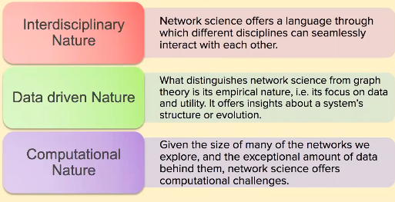

## Intro to Graph Databases

* Types of NoSQL databases reminder
  + 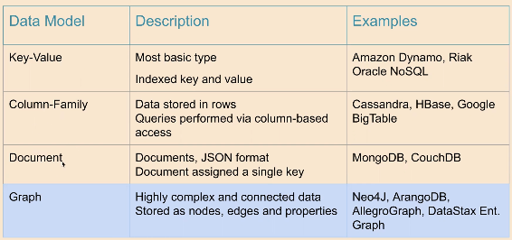
* Data model: property graph
  + RDBMS may indicate that objects are connected, a graph database shows how objects are connected
  + Relationships explicitly embedded in graph data model
  + Graphs foundationally designed to express relatedness
  + More concerned with the relationships (edges) than with the entities (vertexes)
  + Nodes: Entities
  + Edges: relationships between entities
  + 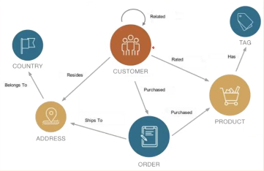
* Comparing graph with relational databases
  + Data generally modelled as relational data
  + Some similarities between relational model and graph model
  + 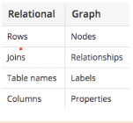
  + But some ways in which relational model differs from graph model
  + 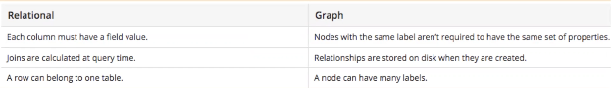
* Whiteboard modelling
  + Very easy to collab with colleagues to come up with whiteboard model of data that is easy to understand and modeify
  + Then use the model to create nodes, relationships, labels, properties you will use for property graph model
* Example modelling – football players transfers
  + 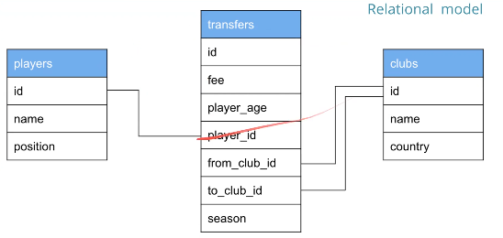
  + 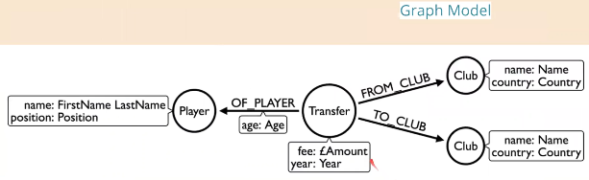
  + In Neo4j, data model might evolve to something like this:
    - 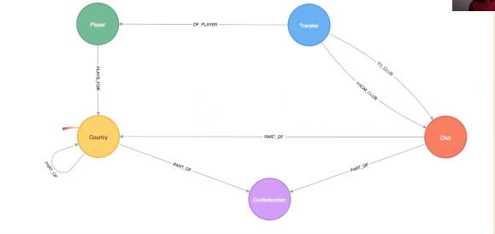
* Use cases
  + Customer 360
    - Understand and analyse customer relationships consolidated across business units for holistic view (for Business Intelligence and others)
    - Graph model is excellent way to consolidate disparate data
  + Personalisation and recommendation
    - Enterprises need influence customers to buy their products
    - Offer relevant products and services
  + Security and fraud detection
    - Determine which entity, transaction or interaction is fraudulent, poses a security risk, or is a compliance concern
    - Graph model is useful because most transactions/interactions cannot be deemed fraudulent in isolation
    - Instead, they can be made in a larger context (e.g. previous transactions, past customer behaviour)
  + IoT and Networking
    - IoT use cases involve devices or machines that generate time-series info such as event and status data
    - Graph model allows to perform analysis on relationships among data elements – understand how they relate to each other over time
* Summary of graph databases
  + Used for storing, managing, querying data that is complex and highly connected
  + Focus on data relationships
  + Data model: property graph
  + Compared graph with relational databases
  + Use cases

## Neo4j and Cypher

* What is Neo4j?
  + Internet-scale, native graph database that leverages connected data
  + Neo4j’s data model is a graph, in particular a property graph
  + Cypher is Neo4j’s graph query language (SQL for graphs)
    - Declarative query language – describes what you are interested in, not how it is acquired
    - Meant to be very readable and expressive
* Libraries and tools
  + 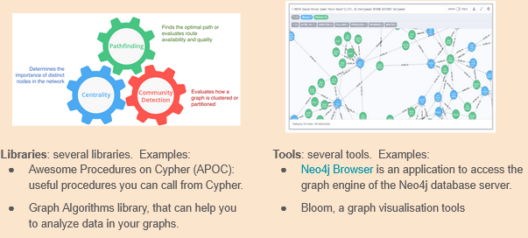
* Cypher
  + Neo4j query language – Create, Read, Update, Delete (CRUD)
  + Declarative query language
  + Optimised for being human read
  + Cypher’s construct uses English prose and iconography (called ASCII art)
* Cypher as a declarative language
  + Focuses on the clarity of expressing what to retrieve from graph, not how to retrieve it
  + Maps English language sentence structure to patterns in a graph
  + 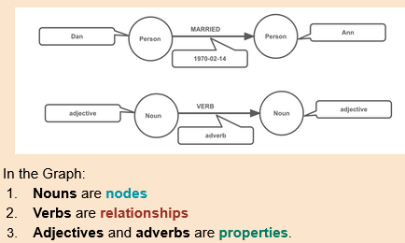
* Cypher as ASCII art
  + 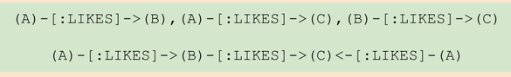
  + Nodes
    - Pair of parentheses (A), (B), (), like circle on whiteboard
    - Nodes can also have labels/names prefixed by a colon, for example (A:person)
  + Relationships
    - Pairs of dashes with greater-than or less-than signs where the < and > signs indicate relationship direction
    - Between dashes, relationship names enclosed by square brackets and prefixed by a colon
* Cypher nodes and labels
  + 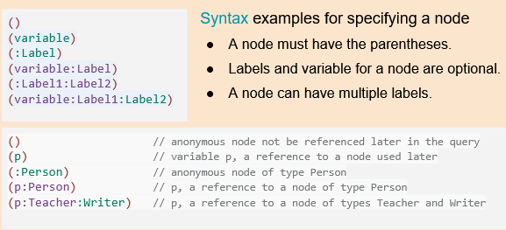
* Cypher structure
  + Similar to SQL – queries built up using various clauses
  + Use pattern matching
  + Most common clauses
    - MATCH – graph pattern to match; this is the most common way to get data from the graph
    - WHERE – not a clause, but rather part of MATCH, and WITH; adds constraints to pattern, or filters intermediate result passing through WITH
    - RETURN – what to return
  + MATCH clause
    - Most widely used Cypher clause
    - Performs pattern match against data in the graph
    - During query, graph engine traverses the graph to find all nodes that match the pattern
    - RETURN clause
      * Used to return nodes or data
      * Must be last clause of query
    - 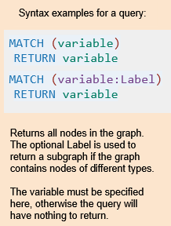
* MATCH clause – retrieving nodes
  + 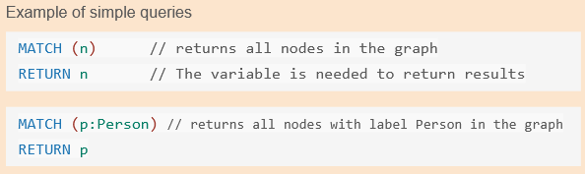
* Retrieving nodes filtered by property value
  + Can filter by specifying a value for a property
  + Any nodes matching the value retrieved
  + One or more values for properties can be used to filter data
  + 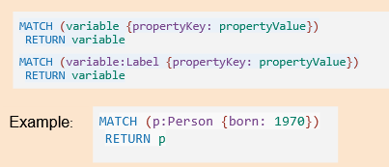
* Querying using relationships
  + 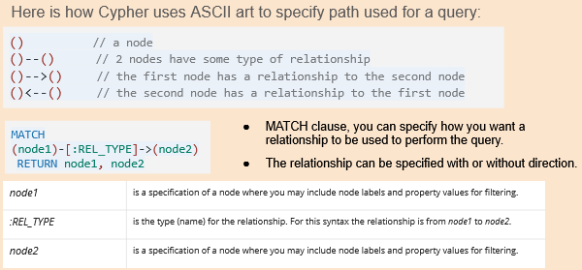
* Cypher clauses for update, delete, create
  + CREATE (and DELETE) – create and delete nodes and relationships
  + 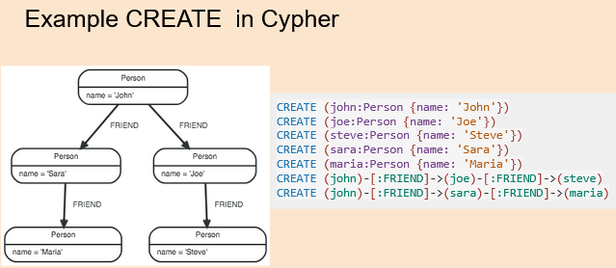
  + SET (and REMOVE) – set values to properties and add labels on nodes
  + MERGE – match existing or create new nodes and patterns; this is especially useful in conjunction with unique constraints
* Examples of MATCH in the graph created
  + 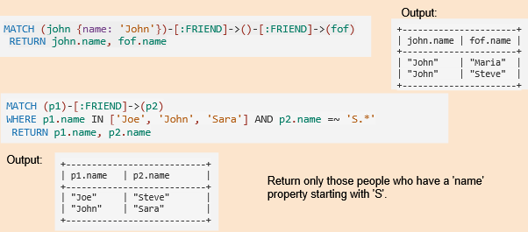
* Summary
  + Neo4j
  + Cypher query language
  + Final Lab – Neo4j browser to visualise and query graph databases